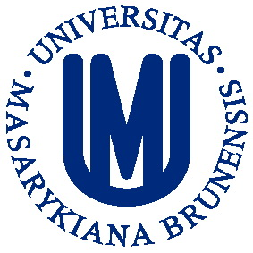

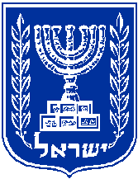
משרד ראש הממשלה
המועצה הציבורית להנצחת זכרו של בנימין זאב הרצל

THEODOR HERZL DISTINGUISHED CHAIR PROGRAM
Seminar for a group of Central European and Israeli Doctorate students
APPLICATION
Seminar dates: February 17th – 20th, 2019
Seminar venue: Masaryk University, Brno (Czech Republic)
Deadline for applications: December 10th , 2018
Submission of application by email to the seminar coordinator.
Information: https://czs.muni.cz/en/staff-from-abroad/research/theodor-herzl#seminar-for-phd-students
Contact: Hoa Nguyenová (nguyenova@czs.muni.cz)
- APPLICANT
Title
First name
Family name
Date of birth
Country of citizenship
Private address
Telephone
E-mail

- PROFESSIONAL PROFILE
Home institution

Mailing address
Current study program and year of studies
Major academic discipline
Other specialization(s)
Foreign language competences

Most significant academic accomplishments
Include items such as significant study and research awards, papers delivered at conferences etc.

Research activity
Summarize your research background and publication activity, indicate your research grants etc.

Study trips abroad of over 1 months
Include the country, purpose and length of your stay

- PAPER DETAILS
Paper title
Key words | List 5 keywords that best describe your proposed paper

Paper outline
Provide a detailed outline of the paper. Min. 500 and max. 2000 characters.

- SEMINAR IMPACT
Describe the expected impact of the participation in the workshop on your professional competences, including teaching/research activities and benefits for your home institution.

- ATTACHMENTS
All applicants are required to submit:
- Curriculum vitae
- A short paper on the given theme
- References (sent by the person who writes the reference to nguyenova@czs.muni.cz)
All attachments must be provided in English.
- SIGNATURE
I, the undersigned, certify that the information contained in this Application Form is correct to the best of my knowledge.

Place: | Date:
Name: | Signature:

